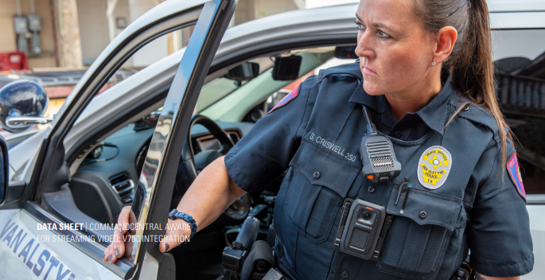

VAN ALSTYNE POLICE DEPARTMENT

JOIN OUR TEAM

WE ARE HIRING

Van Alstyne Police is seeking motivated Certified Police Officers who are
dedicated to making a difference in the community they serve! In exchange, VAPD offers a fantastic opportunity for advancement in a fast-growing city! VAPD also offers the following incentives:

▪ Excellent Salary $68,000 - $90,800 plus Certificate Pay
▪ The City pays the employee’s Health, Dental, Vision, and Life Insurance. The City also pays
for 50% of dependent cost for medical insurance
▪ TMRS 7% (City matches 2 to 1). Vested in five years
▪ Twelve Paid Holidays
▪ Generous Vacation, Sick, and Personal Leave
▪ Twelve hours shifts
▪ VAPD issues all uniforms, duty gear, body armor, duty weapon, patrol rifles, etc.
▪ New state of the art Public Safety Complex currently in the design phase. Construction is slated
to begin later Q4 2023

For more information, contact Lt. Hayslip 903.482.5251 shayslip@vanalstynepolice.com
Applications available at https://cityofvanalstyne.us/departments/human-resources/

