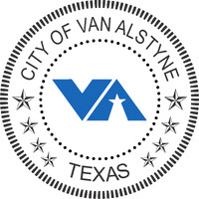

June 17, 2024
Re: Service Line inventory for the City of Van Alstyne
Dear Property Owner/Property Manager,
The City of Van Alstyne has contracted Hardin & Associates Consulting (HAC) to conduct and perform a meter service line inventory/audit/survey.
Over the next several months, inspectors will be conducting inventory, audit and surveying service lines, including water meter boxes, from Mondays through Saturday between the hours of 7am and 7pm. The inventory/audit/survey duration times will vary by location and type of property. The City of Van Alstyne is asking for your assistance and cooperation during this process. Access to premises may be required to complete the service line inventory/audit/survey.
Should you have any questions please contact me at (903) 482-5426 or utilities@cityofvanalstyne.us.
Respectfully,

Jerry Davis
Public Works Superintendent
(903) 482-5426

